

***MICROPROCESSOR AND EMBEDDED SYSTEMS (22442)***

***FINAL PROJECT REPORT***

3D Scanner

group number :29

|  |  |  |  |  |
| --- | --- | --- | --- | --- |
| *Authors:* |  |  | | *Supervisor:* |
| Abdullah Al-Momani  Firas Hussein  Mayar Saidi | Abd20180776@std.psut.edu.jo  Fir20160526@ std.psut.edu.jo  May20180782@ std.psut.edu.jo | CE  EE  NIS | Dr. Belal Sababha. | |

January 21, 2024

Abstract

This project introduces a compact 3D scanner featuring a user-friendly design. It incorporates an IR range (distance) sensor and a lead screw mechanism, which is controlled by a NEMA 17 stepper motor. This configuration enables the sensor to move vertically, capturing detailed readings of an object positioned on a rotating platform.

Introduction and background

We will create a 3D scanner, which is allows the sensor to move vertically, capturing detailed readings of an object placed on a rotating platform.

In our project the machine should begin with the sensor descending to the base of the lead screw, halted by a limit switch. It then takes a reading of the object before the platform makes a minute rotation. This process repeats until a full rotation is completed, providing a comprehensive scan of the object’s surface at that particular height

In addition to a voltage regulator, a micro-SD reader for data storage, and two A4988 stepper motor drivers for exact motor control, the project will make use of a PIC microcontroller for code design.

This 3D scanner is a useful tool for many purposes, from quality control to product development, as it promises to provide high-resolution 3D scans in a small, affordable package.

Design:

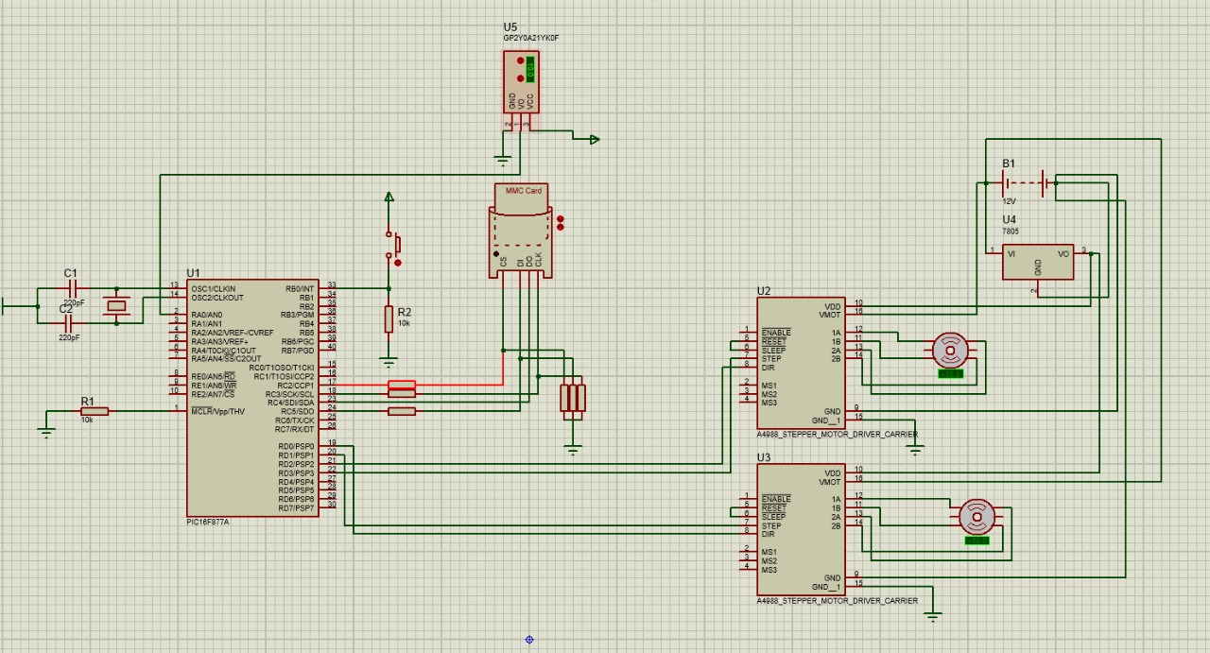Electrical design:

Mechanical design:

We will use these components:

1. IR range (distance) sensor
2. NEMA 17 Stepper Motor
3. A4988 Stepper Motor Driver
4. Limit Switches
5. Voltage Regulator
6. Mini USB MicroSD Card Reader
7. Miscellaneous

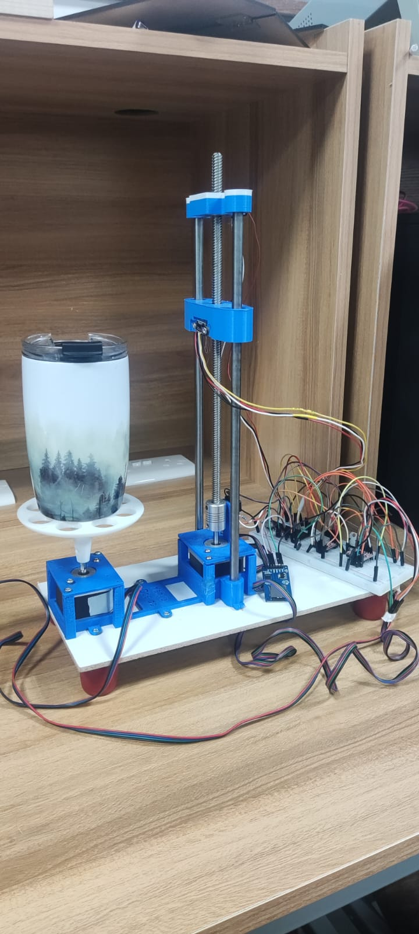

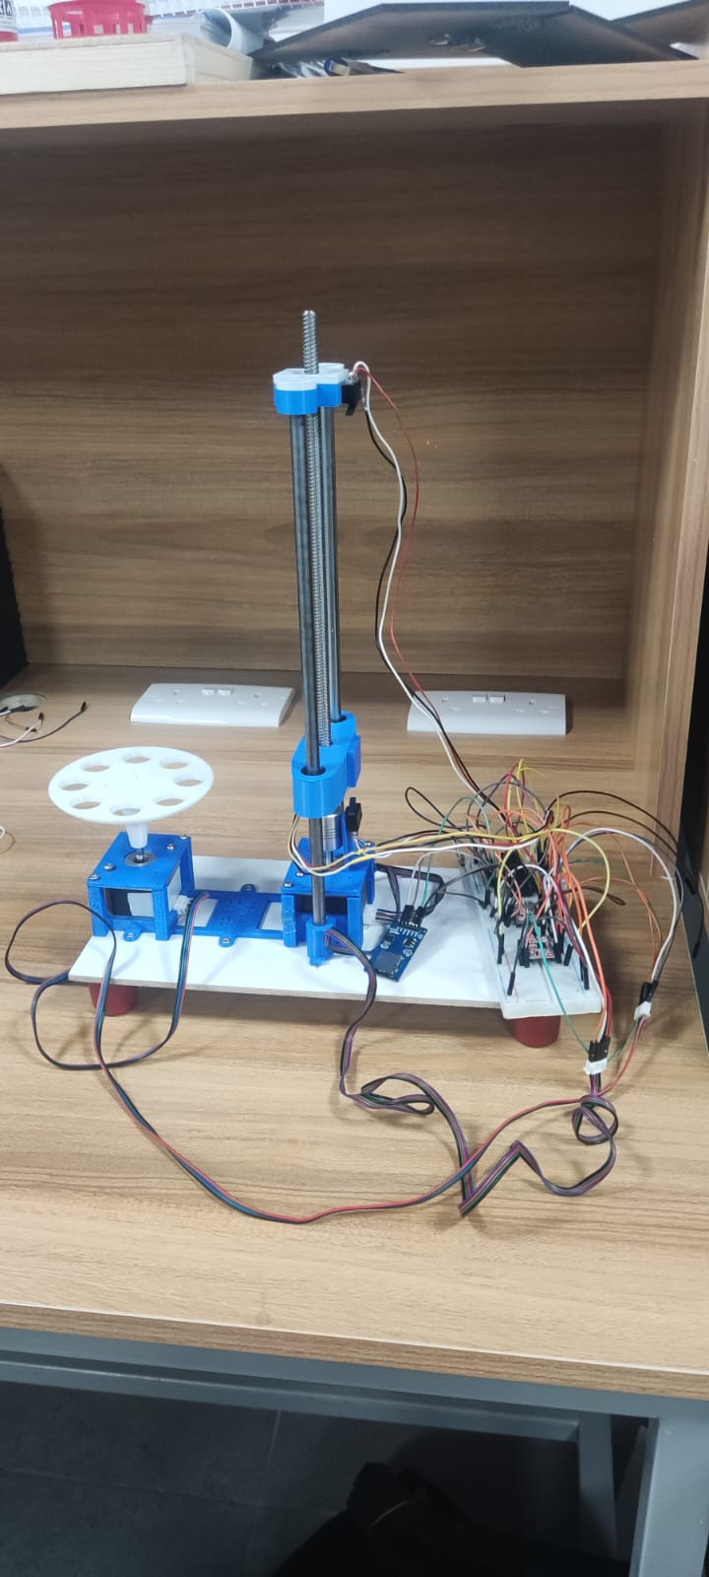

**Software design:**

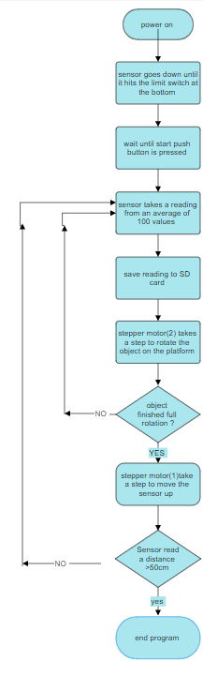

Hardware design:

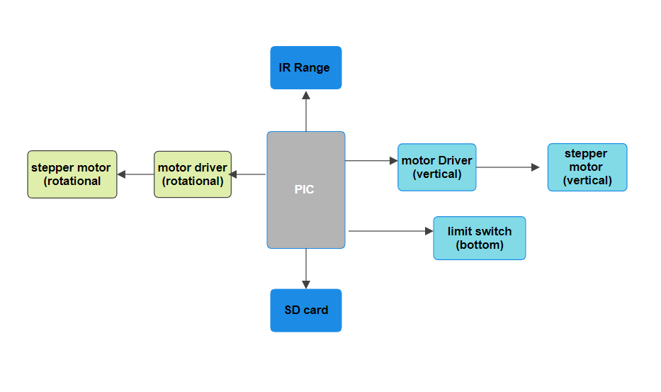

Problems and recommendations:

Software problems:

**Hardware problems:**

We encountered an issue where the components were delicate, leading to the breakdown of more than one piece during manual handling. We suggest having some experience with sensitive components to minimize potential problems. The hardware posed numerous challenges, and we extend our heartfelt gratitude to the student Yahya Obeido for providing significant assistance with the mechanical design and 3D printing aspect of the project.

**References:**

1. https://www.alldatasheet.com/

2.[Stepper Motors: Types, Uses and Working Principle | Article | MPS (monolithicpower.com)](https://www.monolithicpower.com/en/stepper-motors-basics-types-uses)

3. <https://microcontrollerslab.com/stepper-motor-interfacing-pic16f877a-microcontroller>

4.PSUT Elearning using chapter 8 and 9.

**Conclusion:**

Designing a 3D scanner was tough, as it demanded a solid grasp of embedded systems science and plenty of patience for trial and error. Despite the challenges, we're confident in our project. We believe it meets top-notch design standards and functions well.